Comprehensive Data Analysis Report
Data analytics internship- week4
Submitted by: Ankita Navale
Organization: YuvaIntern
Tool used: R and RStudio
Task week 4 – comprehensive data analysis report
1.Introduction:
Data analysis is an important process used to collect, clean, explore, visualize, and interpret data to obtain meaningful insights. During this internship, I worked on different stages of data analysis using R and RStudio. The activities included data preparation, exploratory data analysis, visualization, statistical analysis, hypothesis testing, and predictive modeling.
This report presents a comprehensive summary of the work completed during the previous weeks of the internship. The analysis involved dataset such as the Titanic dataset and the Iris dataset. Different statistical and machine learning techniques were applied to understand patterns in the data and evaluate the performance of predictive models.
The main objective of this task is to combine the previous analysis into one structured report and present the finding in a clear and understandable manner. The report also discusses the result obtained, the learning outcomes challenges encountered during the analysis, and possible future applications of the data analytics.
R and RStudio were used throughout the analysis because they provide useful tools for statistical calculations, data visualization, hypothesis testing, and machine learning.
2.Dataset Description:
For this internship, different datasets were used to perform data analysis and machine learning tasks. The main datasets used during the previous weeks were the Titanic dataset and the Iris dataset
2.1Titanic Dataset:
The titanic dataset contains information about passengers who travelled on the titanic. It included variables such as passenger class, gender, age, number of siblings or spouses, number of parents or children, ticket fare, and survival status. The dataset was used for data cleaning, exploratory analysis, and visualization.
The titanic dataset contains 891 observation and 112 variables. It helped in understanding passenger characteristics and identifying pattern related to survival.
2.2. Iris dataset:
The iris dataset contains measurement of iris flowers from three different species: setosa, versicolor, and virginica. The variables included sepal length, sepal width, petal length, and petal width.
The iris dataset was used for statistical analysis, correlation analysis, normality testing, hypothesis testing, and decision tree classification. The dataset contains 150 observation and 5 variables, including the species/classification variable.
3. Tools and Technologies:
The analysis was performed using R and RStudio. R was used for data manipulation, statistical analysis, visualization, hypothesis testing, and predictive modelling. RStudio provided an environment for writing and executing R commands and analyzing the results.
4.Data preparation and cleaning:
Data preparation is an important step in the data analysis process because the quality of the data directly affects the accuracy of the analysis. Before performing statistical analysis and visualization, the datasets were examined and prepared using R and RStudio.
4.1Titanic dataset preparation
The titanic dataset was imported into RStudio and its structure, dimensions, and variables were examined. The dataset contained 891 observations and 12 variables. The variables were checked to understand their data types and identify missing or inconsistent values.
Basic descriptive statistics were generated for numerical variable such as Age and fare. The data was then prepared for exploratory analysis and the visualization. Appropriate variables were selected to study relationship between passenger characteristics and survival.
4.2. Iris Dataset preparation:
The iris dataset was loaded into RStudio and its structure and summary statistics were examined. The dataset contains 150 observations belonging to three species: Setosa , versicolor, and Virginica.
The variables were checked for their data types and consistency. Summary statistics were calculated for sepal length, sepal width, petal length, and petal width. The dataset was then prepared for correlation analysis, normality testing, hypothesis testing, and decision tree classification.

4.3 Data Analysis Environment:
All data preparation and analysis activities were performed using RStudio. Function and commands in R used to inspect the datasets, calculate summary statistics, create visualizations, perform statistical tests, and build the predictive model.
5.Exploratory Data Analysis:
5.1 Summary statistics
Summary statistics were calculated to understand the main characteristics of the dataset. Measures such as mean, median, minimum, maximum, and standard deviation were used to identify the central tendency and variability of the data. These statistics provide an overall understanding of the dataset and help identify unusual values or patterns.
5.2 Distribution Analysis:
The distribution of the variables was examined using appropriate graphs and statistical measures. Histograms and other visualizations were used to understand the spread, frequency, and distribution of the data. The analysis helped identify common patterns, variations, and possible in the dataset.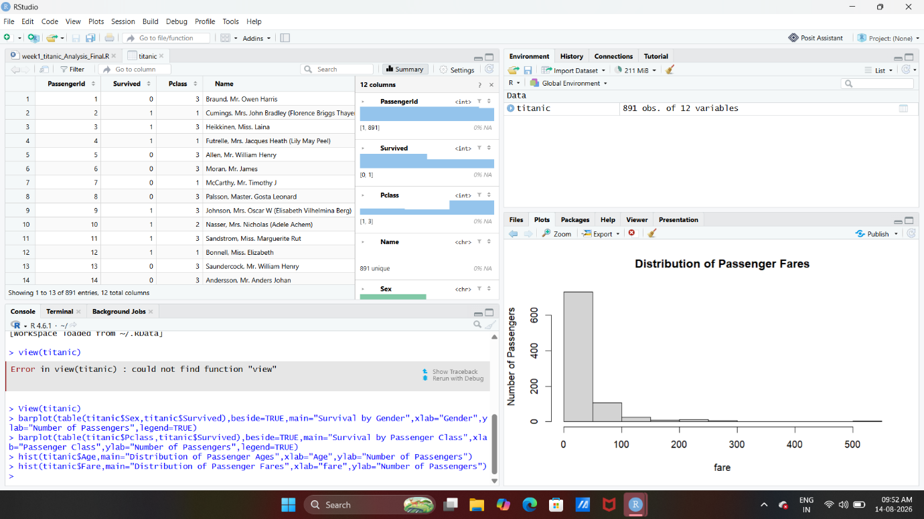

The distribution of passenger fares was analysis using a histogram. The graph shows how passenger fares are spread across different ranges and helps identify the most common fare values and possible extreme values.

5.3 Correlation Analysis:
Correlation analysis was performed to examine the relationship between numerical variables in the dataset. It helps determine whether changes in one variable are associated with changes in another variable. The correlation results were used to identify positive, negative, or weak relationship between the variables.
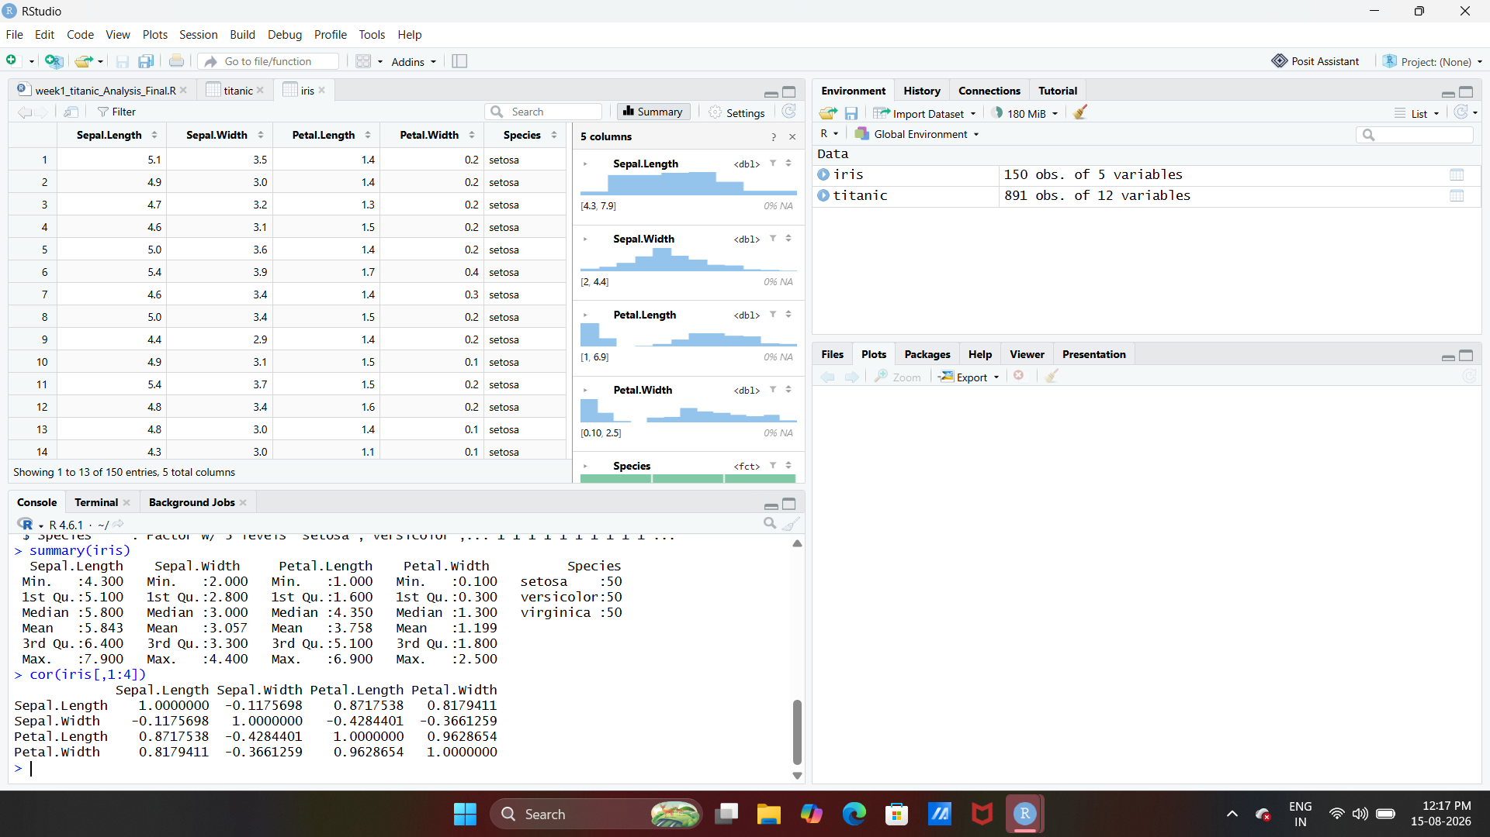
The correlation matrix shows the strength and direction of relationship among the numerical variables of the Iris dataset.
5.4 Data visualization:
Data visualization was used to represent important patterns and relationship in the dataset through graphical methods. Different types of charts and plots help make the data easier to understand and allow important trends, comparisons, and patterns to be identified clearly.
4.1 Bar chart:
A bar chart was used to compare the values of different categories in the dataset. It provides a clear visual representation of differences between categories and helps identify which categories have higher or lower values.

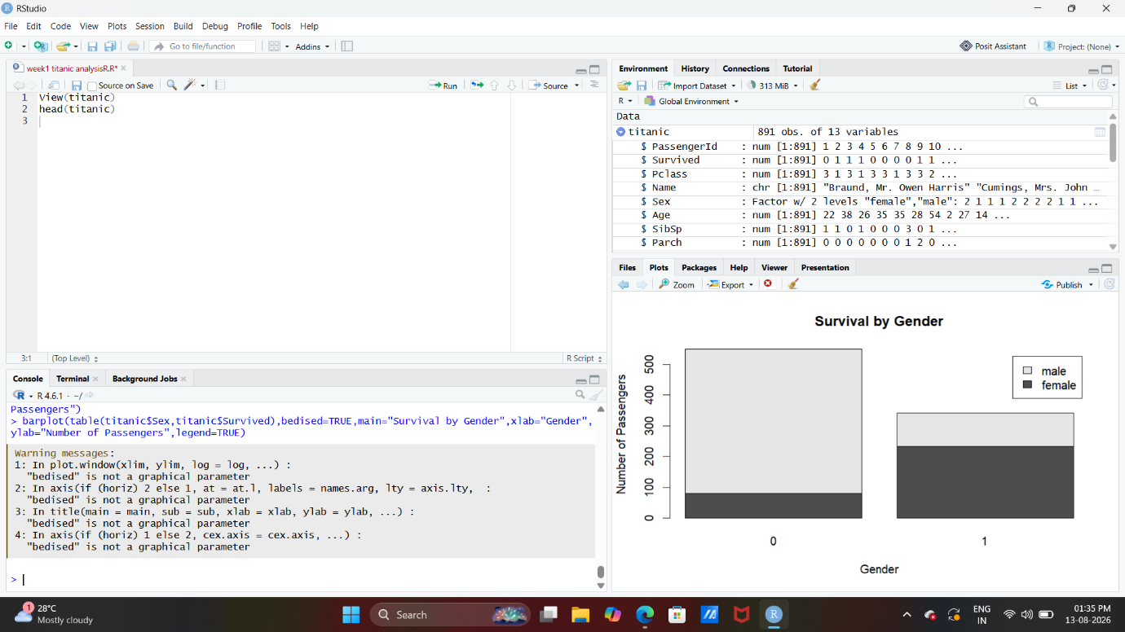
The bar chart compares the survival status of passenger based on gender.
4.2 Histogram:
A histogram was used to show the frequency distribution of the numerical variables. It helps visualize how the values are spread across different ranges and makes it easier to identify common values and variation in the dataset.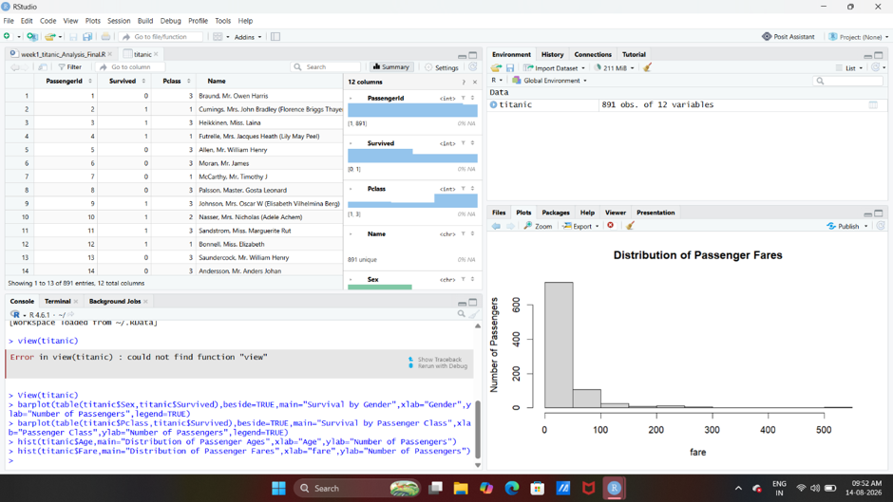
The histogram shows the distribution of passenger fares in the titanic dataset. It helps us to understand how the fare values are spread across different ranges.

4.3 Scatter plot:
The scatter plot is used to visualize the relationship between two numerical variables. Each point represents an observation from the dataset. It helps identify patterns, trends, and the strength of the relationship between the selected variables.

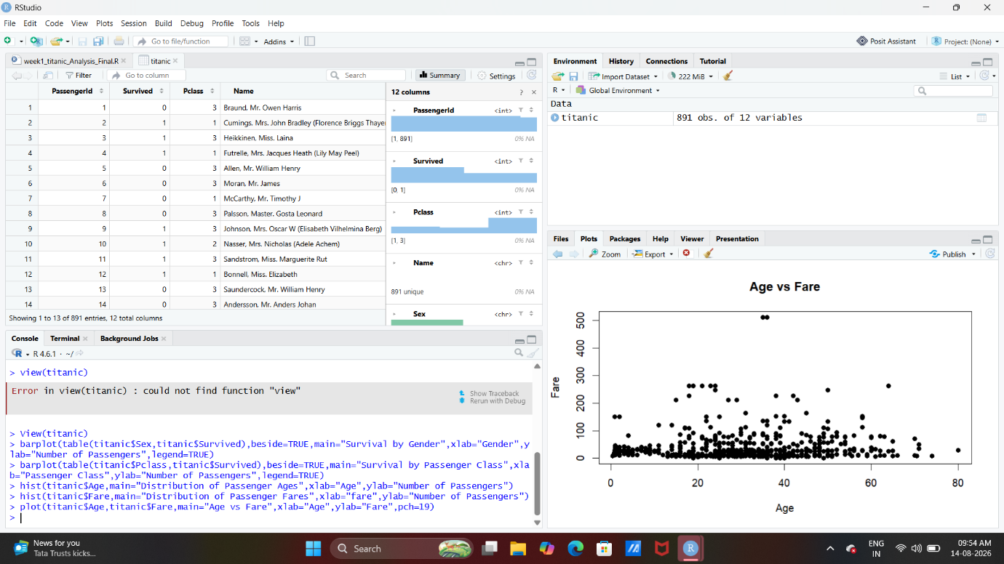
The scatter plot shows the relationship between passenger age and fare in the titanic dataset.
6.Predictive and statistical Analysis:
Statistical analysis was performed to understand the relationship and patterns present in the dataset and to support meaningful conclusions. Different statistical techniques were applied using R to examine the data and evaluate important characteristics. The analysis included statistical testing and predictive modeling where appropriate. These methods helped identify significant patterns, relationship between variables, and factors that may influence the outcomes. The results obtained from the analysis were used to support the findings presented in the following sections.
6.1 statistical testing
Statistical testing was performed to determine whether the observed patterns in the dataset were statistically significant. The tests helped evaluate relationship or differences between variable and provided evidence for drawing reliable conclusion from the data.
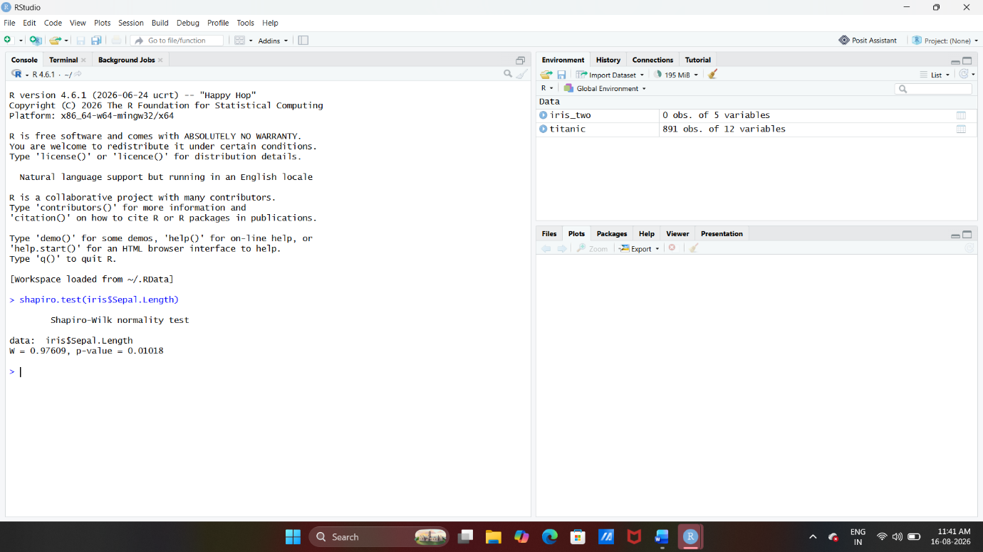
The Shapiro wilk test was used to check whether the data follows a normal distribution. The test produced a w value of 0.97609 and a p- value of 0.01018.
6.2 Predictive Modeling
Predictive modeling was used to identify patterns in the data and make predictions based on the available variables. A suitable machine learning model was developed using R to understand how the input variable can be used to predict the target outcomes.
6.3 Decision tree model
A decision tree model was used to predict the target outcome based on the selected input variables. The model represents decision making through a treelike structure where internal nodes represent conditions, branches represent possible outcomes, and leaf nodes represent the final predictions.
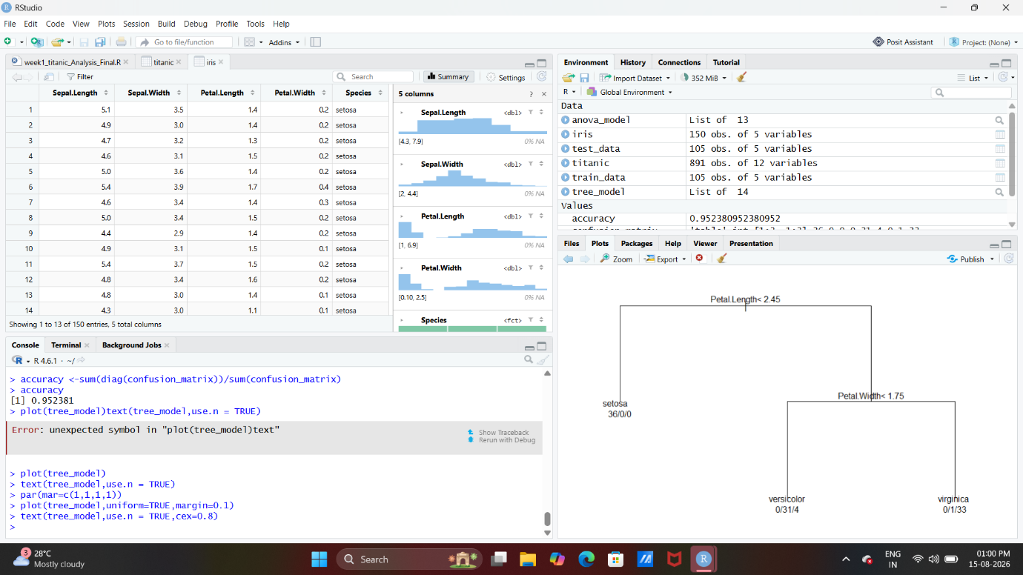
The decision tree shows how the selected variables are used to classify the observation into different categories. The tree begins with the most important variable at the root and uses conditions to split the data into smaller groups. The final nodes represent the predicted classes. This visualization helps understand the decision making process of the model.
6.4 Model Evaluation
Model evaluation was performed to assess how effectively the predictive model classifies the data. Evaluation the predictive model classifies the data. Evaluation measures helps determine the model performances and reliability by comparing the predicted results with the actual outcomes.
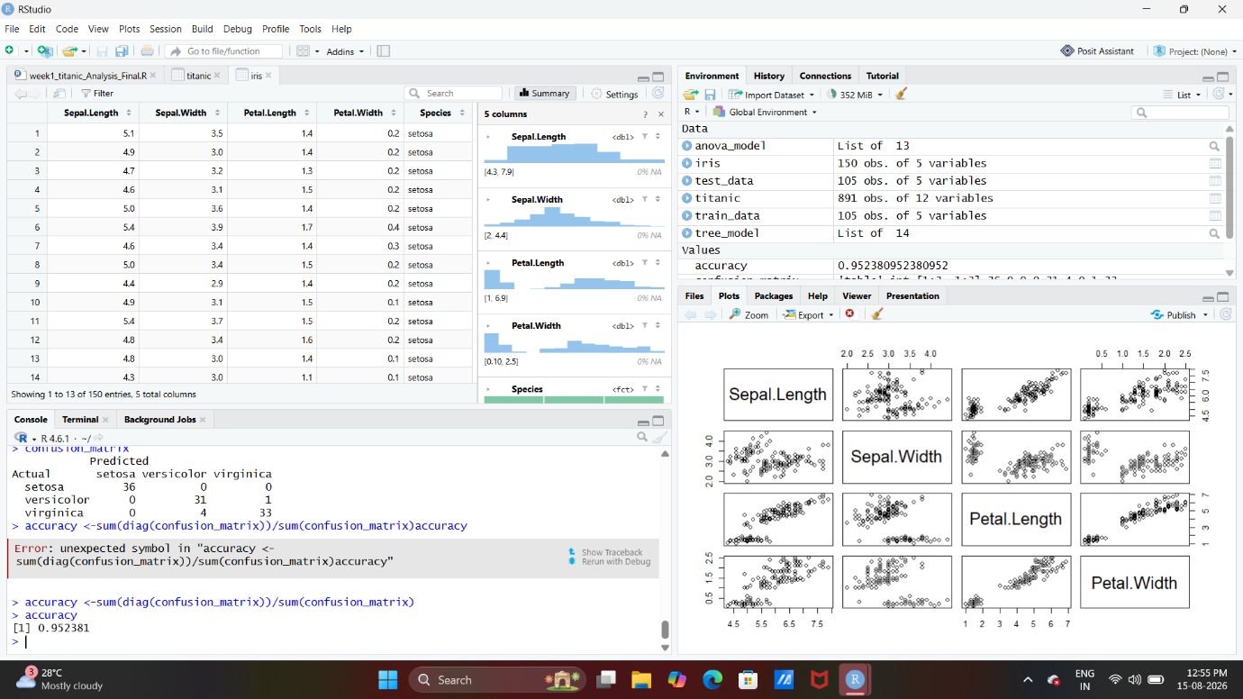
The confusion matrix compares the actual values with the predicted values generated by the model. It helps to identify the correctly and incorrectly classified observations. The model achieved an accuracy of 0.952381, which means the approximately 95.24% of the observations were correctly classified. This indicates that the model performed well on the given dataset.
6.5 results and finding:
The analysis provided useful insights into the dataset and helped identify important patterns and relationships among the variables. The statistical testing, predictive modeling, and model evaluation results indicate that the applied methods were useful for understanding the data and making predictions. The findings obtained meaningful conclusion from the study.
Conclusion
The analysis of the dataset was successfully performed using R and various statistical and data analysis techniques. Data preparation, exploratory, data analysis, visualization, statistical testing, and predictive modelling helped identify important patterns and relationship in the data. The decision tree model also provided useful predictions, with an accuracy of approximately 95.24%. overall, the analysis demonstrate how statistical and predictive techniques can be used to understand data and support meaningful conclusion.

